Day 23 Rise of David (1 Samuel 16-31): Readings 1 Samuel 16-20; 24-25; 28; 31
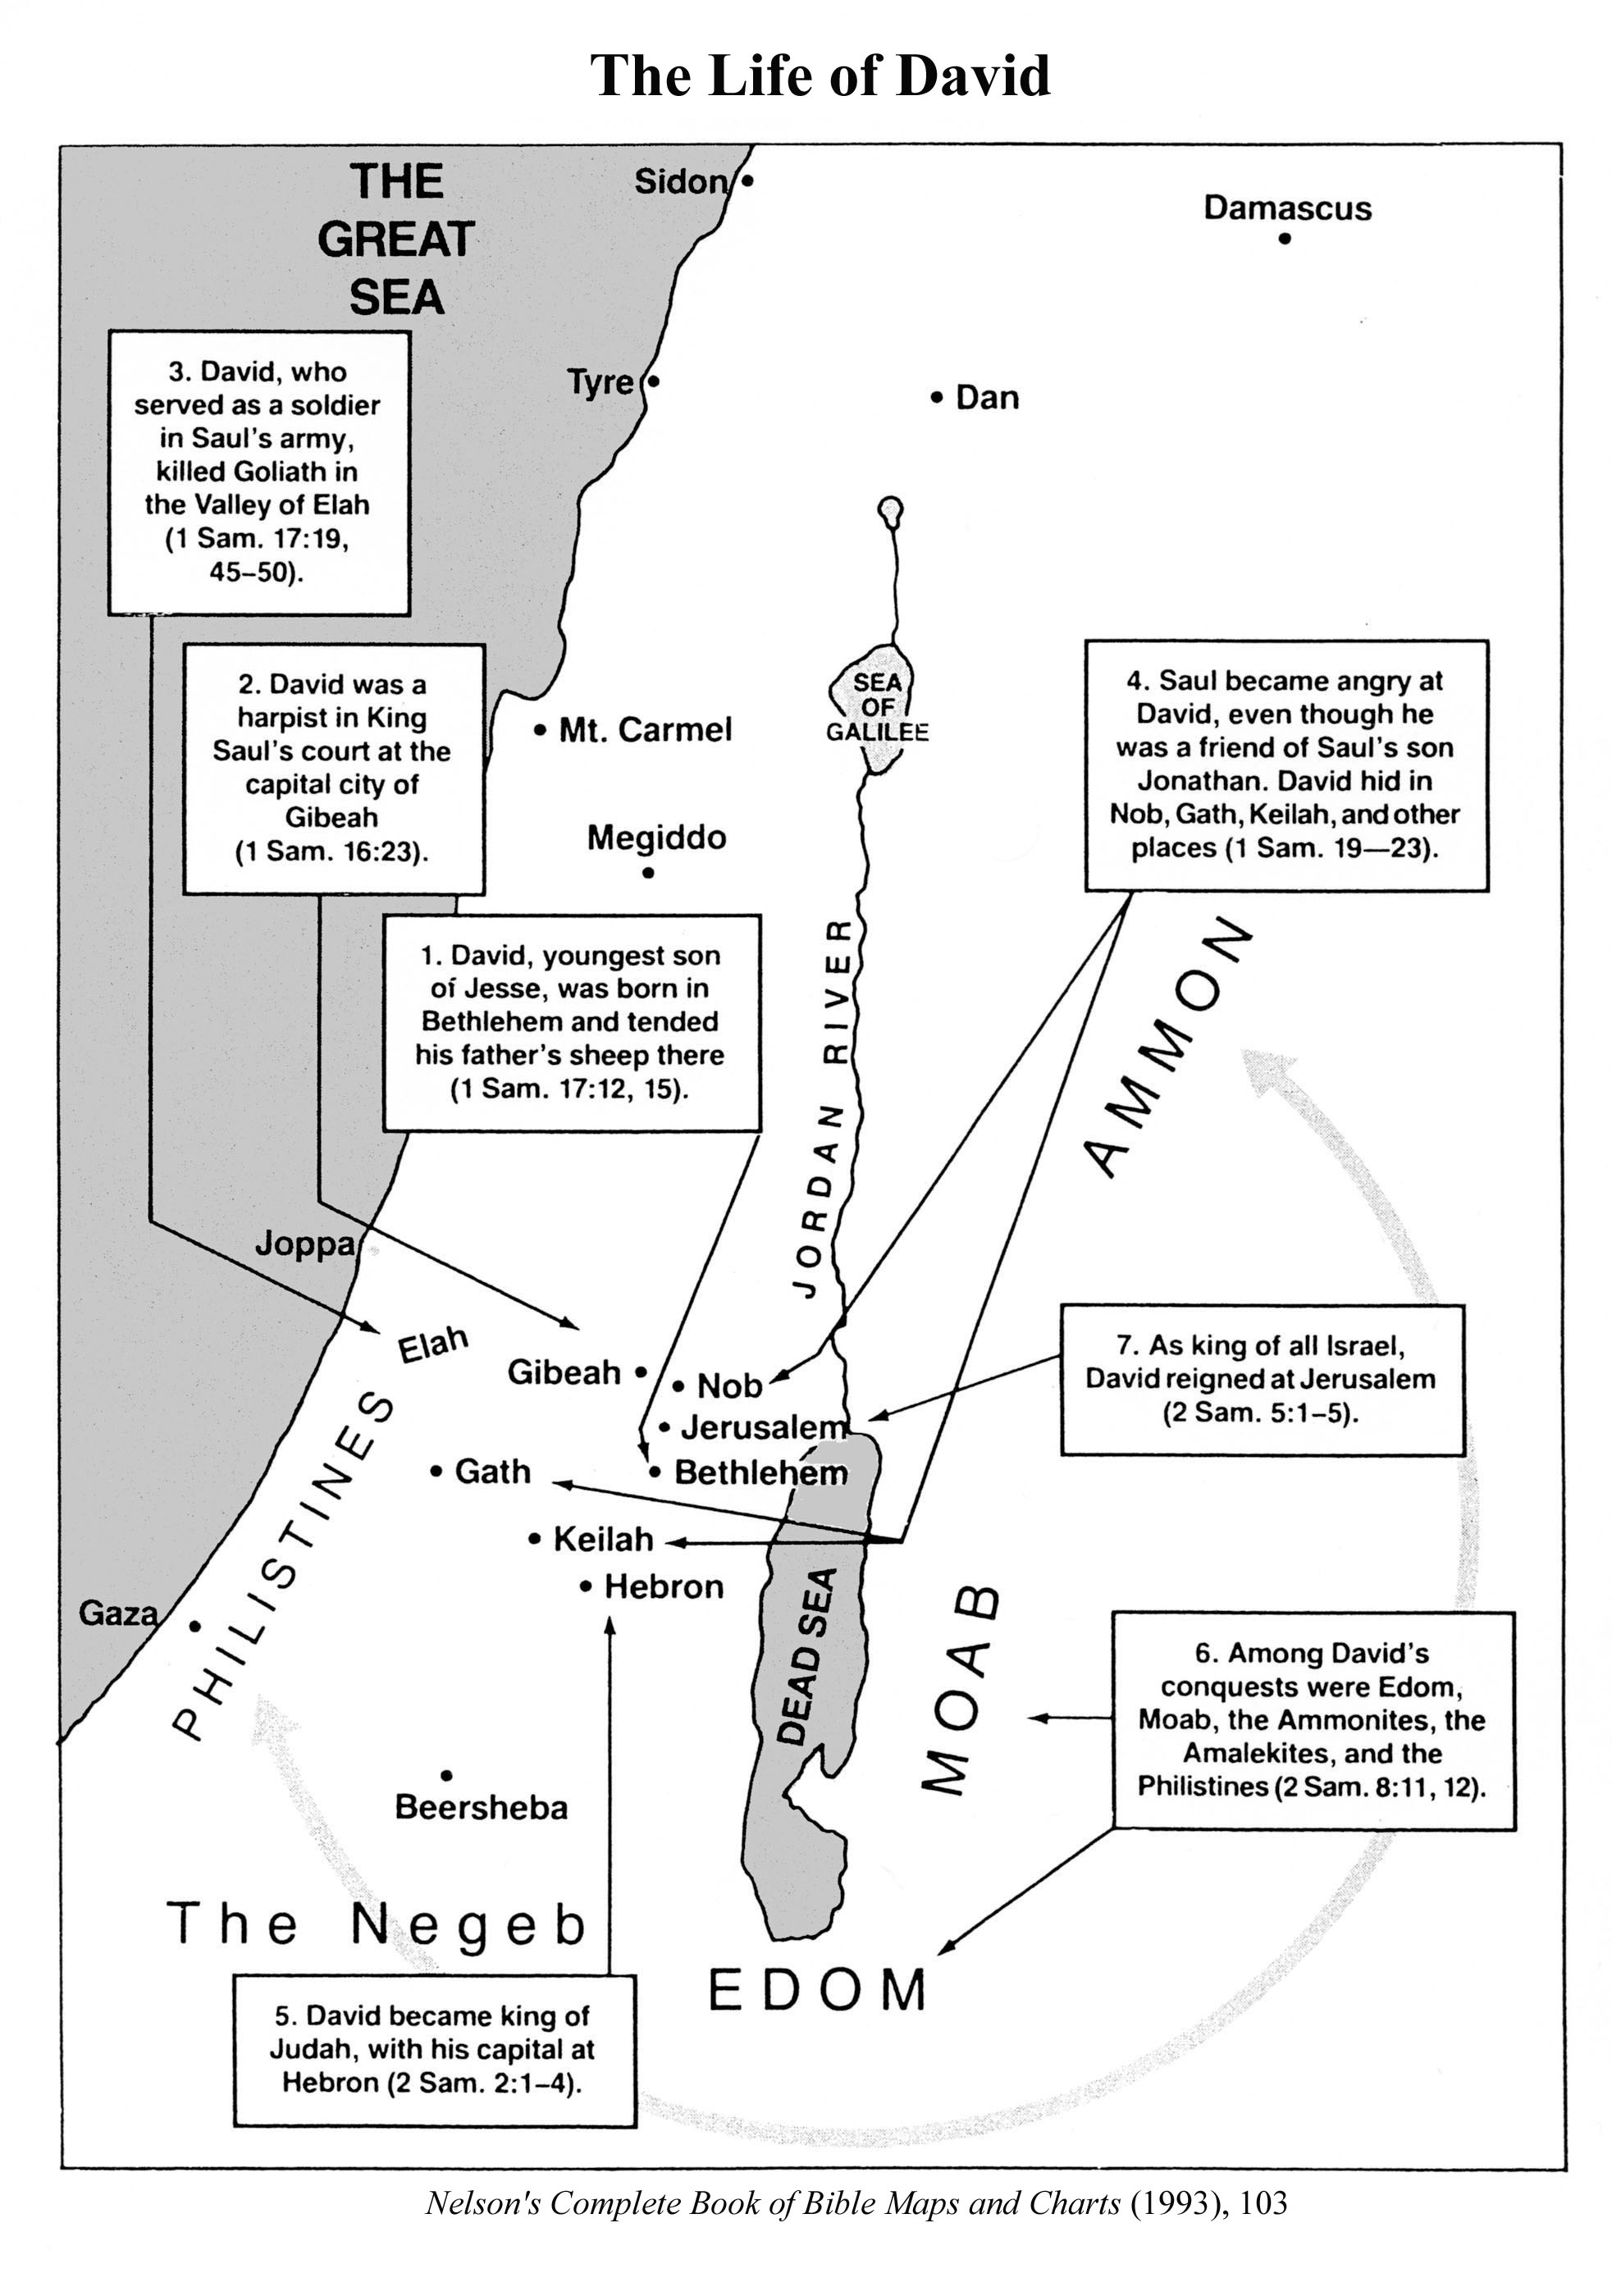
The History of the Rise of David
The History of the Rise of David describes how David became king even though he was not in any line of succession to Israel’s throne. The biblical text argues that David’s predecessor was impious and therefore rejected by God as king. It suggests that Saul and his own choice as successor, his son Jonathan, were killed in battle by their enemies. The biblical text repeatedly makes the point that David was always loyal to Saul and never sought to seize the kingdom from him. Indeed, David had several opportunities to kill Saul but refused to do so. This was true to such an extent that Saul blessed David for what he had done and proclaimed David’s righteousness. Jonathan was close to David and recognized his legitimacy as the chosen successor to Saul. Indeed, again and again David is portrayed as blessed by God, chosen by him to be Israel’s king, and successful in all his battles and other endeavors. When Saul and Jonathan are killed in battle, David is physically away from the scene and has no role in their deaths. He eulogizes them and seeks to do good to Saul’s descendants, especially those in the line of Jonathan, such as his son Mephibosheth.
Richard S. Hess The Old Testament, 259.

Historical Background
“Sources for this period of history are scarce. Neither Egypt nor Mesopotamia was in any position to look beyond its borders, so small nations of Syro-Palestine were left to squabble among themselves. Threats to Israel posed especially by the Philistines necessitated a greater amount of cooperation among the tribes than was the case previously, and these are directly responsible for the decision to switch to a monarchic form of government. Saul had occasional victories over the Philistines, but he died in battle at Mount Gilboa and the Philistine overran at least the central portion of Palestine. It was left to David, therefore, to drive out the Philistines. David was also successful in extending Israelite control over most of Syro-Palestine through a series of conquest and treaties.”
Hill & Walton Survey of the Old Testament 259

A power vacuum enabled the city-states of the previous Late Bronze Age to consolidate their power into nations that were small by comparison with Egypt or Assyria but larger than their predecessors.

Iron Age I (1200-1000 BC) & the Empire of David & Solomon (1000-900 BC)
The beginning of the Iron Age brought the fall of the Hittite Empire, the destruction of many of the major port cities of Syria including Ugarit, Tyre, and Sidon as well as fortified cities such as Megiddo and Ashkelon, a lull in Assyrian power, and substantial decline in Egyptian influence. Much of this political upheaval is blamed on the invasion by a coalition of tribes called the Sea Peoples who appear to have come from the Aegean region by ship as part of a massive population movement. It is difficult to ascertain what role they had in the destruction of the fortified cities and the fall of the Hittite Empire, but records show they were repelled by the Egyptians after massive sea battles exacted heavy casualties. One of the Sea People tribes, the Philistines, settled on the southwest coast of Canaan. It is from them that the name Palestine is derived.
This period brought the technological development of iron tools and weapons, knowledge of which helped establish Philistine supremacy over Israel (see 1 Sam. 13:19-23).
The resulting situation in the Near East was that international politics was virtually eliminated. With no major powers left to exert control, relatively minor skirmishes in localized areas replaced the massive military campaigns of empires. The resulting power vacuum allowed for the development of empire building on a smaller scale such as that most evident in tenth-century Israel. . . .
Toward the end of the judges period the Philistines had been contained by the activities of Samson, though they were in control in Judah (Judg 15:11). During the time of Samuel, they overran the hill country and destroyed Shiloh (1 Sam. 4) but were later driven back (1 Sam 7). Saul was successful in maintaining the equilibrium throughout most of his reign, but after the battle of Mount Gilboa (in which Saul was killed), the Philistines occupied most of the midsection of Canaan.
When David came to the throne, one of his first tasks was to regain control of Israelite territory. This was accomplished from his newly conquered, fortified base in Jerusalem. After the Philistines were subdued, David’s military success continued with the eventual subjugation of most of Syro-Palestine. Some countries were annexed, with military governors ruling in place of native kings (e.g. Ammon); others were conquered but became vassal states (e.g. Moab); some paid tribute and became the site for Israelite garrisons (e.g. Aram-Damascus, Edom); and still others became willing vassals (e.g. Hamath).
Hill & Walton Survey of the Old Testament 191-192

Warfare
The fact that milhama, “warfare,” appears over three hundred times in the Bible attests that warfare was a prominent feature of Israel’s history. When the North (Israel) and the South (Judah) were not fighting a common enemy, they were fighting each other. Several factors account for biblical Israel’s frequent military encounters with neighboring people, among them Israel’s strategic location at the crossroad of the ancient world, with Mesopotamia to the northeast and Egypt to the southwest. Israelite territory had a special appeal to imperial powers, since the primary trade routes between Egypt and Mesopotamia, connecting with the Mediterranean seaports passed through Israel. For this reason, Assyria invested Israel and turned it into a province, but let Judah remain. Judah was not very important to Assyria until about 700 B.C.E., and even then was not worth turning into a province
King and Stager, Life in Biblical Israel, 223

The Book of Samuel and the Dead Sea Scrolls
Scholars have long recognized that the book of Samuel in the traditional Hebrew Bible—the Masoretic Text—contains a number of mistakes and other textual challenges. Fragments of four copies of Samuel were discovered among the Dead Sea Scrolls. One of these—4QSamª, copied about 50 BC—has contributed significantly to better understanding the textual history of the book of Samuel. While 4QSamª often agrees with the Masoretic Text, it also preserves readings that agree with the Greek Septuagint against the Masoretic Text and sometimes preserves independent readings not attested elsewhere.
Such textual variants, found in 4QSamª and other biblical manuscripts from Qumran, highlight the status of the biblical text at the turn of the era. They further illustrate that readings in the Septuagint that differ from the Masoretic Text were often based on Hebrew manuscripts that likewise differed from proto-Masoretic Text manuscripts. Two examples of important readings in 4QSamª are cited here. …

How Tall Was Goliath?
The Masoretic Text gives the height of Goliath—the Philistine giant from Gath who challenged Saul’s army—as “six cubits and a span” (1 Sam 17:4). A cubit was about 1.5 feet, and a span was about six inches. So, according to the Masoretic Text, Goliath was about 9.5 feet tall—a real giant. However, the Septuagint preserves Goliath’s height as “four cubits and a span.” According to this reading, Goliath was about 6.5 feet tall, three feet shorter, but still about one foot taller than the average male at that time. Although 1 Samuel 17:4 is not well-preserved in 4QSamª, it likewise reads “four cu[bits] and a span.” This agrees with Goliath’s height as given in the Septuagint and in the [1st century AD] writings of Josephus.
The shorter height of Goliath is probably more accurate. Both 4QSamª and the Septuagint cite Goliath as four cubits and a span, while later Greek copies of Samuel read five cubits and a span, and the Masoretic Text reads six cubits and a span. A scribal process of “growing” Goliath to make David’s victory more impressive may be behind the differences attested in these biblical manuscripts.
Holzapfel, Pike, and Seely, Jehovah and the World of the Old Testament (2009), 199.

The Lord’s Anointed
The practice of anointing was widespread in ancient Israel and throughout the ancient world. In Israel individuals called to three specific offices were anointed: prophets (1 Kgs 19:16), priests (Exod 29:7-9; Lev 8:10-12), and kings (1 Sam 10:1). The ritual of anointing, performed by pouring or smearing oil on the head of the individual to be anointed, was often done in conjunction with washing and clothing in new clothes and was accompanied by blood sacrifice. Anointing was done with olive oil, which was sometimes mixed with perfumes and spices. Olive oil was associated with prosperity, wealth, cleansing, healing, and purity and symbolized the Spirit. One who was anointed was called meshiaḥ, “anointed one,” which derives from the Hebrew verb mashaḥ, “to anoint.” Thus, the prophets, priests, and kings could all be properly referred to as messiahs. King David as the “anointed one” was a type of the future Davidic king who is referred to as the Messiah.
Anointing signified several things. First, it indicated a change of status or setting apart to a divinely inspired calling. Second, anointing was a symbol of purification. In the case of priests (Lev 8:6-9), brides (Ezek 16:9-13), lepers (Lev 14:8-20), and maybe kings, anointing was accompanied with washing and dressing in new clothing. Third, anointing was a symbol of consecration—or the making of something or someone “holy.” For example, the sacred furnishings of the Tabernacle were anointed with oil to consecrate them for the worship of Jehovah (Exod 30:26-29). Fourth, anointing was often connected with the Spirit. Samuel was called by the Lord to anoint Saul as the first king of Israel (1 Sam 10:1). On that occasion Samuel promised Saul that the Spirit of the Lord would come upon him, which occurred when Saul met with a company of prophets (1 Sam 10:6, 9-11). After the Lord rejected Saul because of his sins, Samuel was sent to anoint David: “Then Samuel took the horn of oil, and anointed him in the midst of his brethren: and the Spirit of the Lord came upon David from that day forward. … But the Spirit of the Lord departed from Saul” (1 Sam 16:13-14). Although the Lord had rejected Saul, for a time in ancient Israel there were two men who were “the Lord’s anointed”; Saul was still the anointed king and David had been anointed to become king. Whereas Saul, in his jealousy, sought to kill David, on two occasions when David had an opportunity to harm Saul, he responded that he would not stretch out his hand against “the Lord’s anointed” (1 Sam 24:7; 26:9).
Holzapfel, Pike, and Seely, Jehovah and the World of the Old Testament (2009), 197.

Davidic Covenant 2 Samuel 7:8-17
Yahweh’s oath to preserve the Davidic dynasty and by implication Jerusalem as well led eventually to a popular belief in the invincibility of the holy city. In addition, the belief in Israel’s ultimate redemption became bound up with David and his dynasty. David was idealized by later biblical and postbiblical tradition and became the paradigmatic king. The promise of a Davidic dynasty did not die even when Judah fell to the Babylonians in 586 B.C.E. Following the destruction, the community looked to the future for a restoration of the Davidic line, a Davidic king or messiah. The Hebrew word messiah means “anointed”—a reference to the fact that kings were initiated into office by means of anointing oil poured on the head. King David was thus a messiah of Yahweh, that is, an anointed king, as was every king and high priest in Israel. And in exile, Israelites would pray for another messiah—another anointed king of the house of David appointed by Yahweh to rescue them from their enemies and reestablish them as a nation at peace in their land, as David had done. The Jewish hope for a messiah was thus always political and national, involving the restoration of the people in its land under a Davidic king.
Hayes, Introduction to the Bible, 211.

